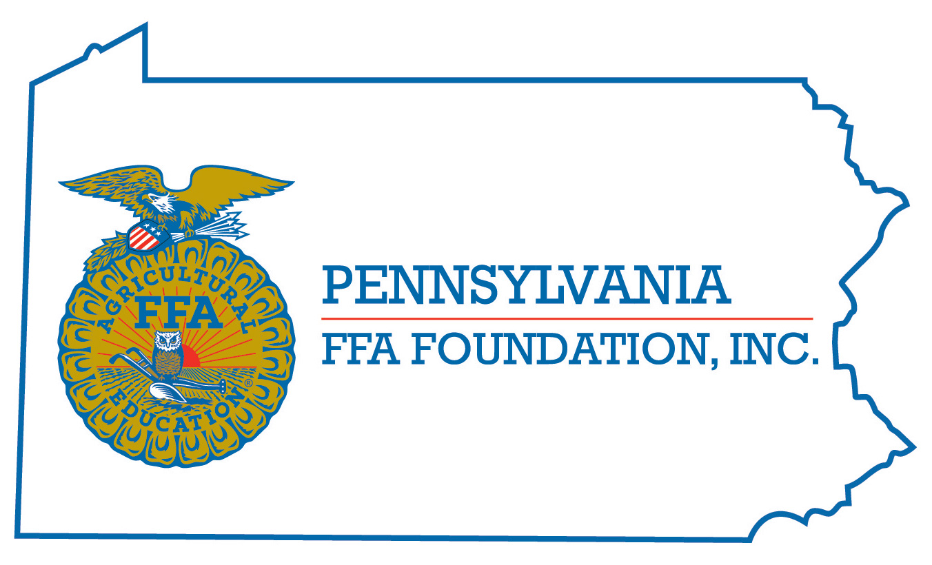
PA FFA Creed Speaking
Leadership Development Event

Chairperson Information
CDE Chairperson | Douglas G. Brown
Email | dbrown@ccsd.cc
Best Contact Number | 814-203-3376
Contest Date/Times | June 13, 2023 @ 12:30 pm and June 14, 2023 @ 8:00 am
Contest Location | Willard Building
LDE Review Time | June 13, 3:30 pm and June 14, 12 pm
LDE Review Location | Willard Building

Basic LDE Guidelines
Event Type: Individual | # of Team Members: 0
Memory of Creed | - No items needed
Official FFA Dress | Recite FFA Creed from memory and answer questions from judges about the Creed
Advanced through area and regional competition

None

LDE Rules
CDE Component | Points | Component Description
Oral Communications | 30 | Contestant must recite FFA Creed from memory
Non-Verbal Communication | 30 | Contestant must provide eye contact, Mannerisms, Gestures and Poise to presentation
Question and Answers | 40 | Contestant must provide responses to judges’ questions pertaining to FFA Creed
 | 100 point total for LDE
Causes for Disqualification: No shows for the event
Tie-breaker: Answers/Response to Questions

Resources
Official FFA Manual and LDE Rules posted to National & State FFA Website

