Dear Friends of Pennsylvania FFA Alumni:
The Pennsylvania FFA Alumni is committed to embracing opportunities, experiences, friendships, and growth as individuals throughout this school year and help FFA members write a beautiful year of FFA experiences. Over the past seventeen years, the Pennsylvania FFA Alumni Association has worked diligently to provide 6,147 Pennsylvania FFA members the first step in a student’s success in this organization, which is affording them with a National Blue and Corn Gold corduroy jacket.
As an alumni organization, we hope to present 400 students with jackets this winter. To reach our goal, we are asking for your help. For $75 you can sponsor a jacket for a first year FFA member. If you are interested, you may send a check, payable to Pennsylvania FFA Alumni Association, c/o Krista Pontius, 405 East Sunbury Street, Millerstown, PA 17062 or visit www.paffa.org/about-alumni to use a credit card via PayPal. Donations for the January 2024 Convention presentation will be accepted until November 15, 2023.

We will provide FFA jackets to all participating chapters across the state, but, if you would like, we will provide an opportunity for you to select which chapter or county you would like to support. Please note, there is a chance that a certain chapter may get more financial support than students who need jackets, so please indicate on the form if you would like the money returned or if you would like to sponsor a student from across the state. As alumni, we know the tremendous number of opportunities that lay before each of these young FFA members and the excitement of becoming a part of this life-changing organization.

The Pennsylvania FFA Alumni secures the promise of the FFA mission and agricultural education by creating an environment where people and communities can develop their potential for premier leadership, personal growth, and career success. Thank you for considering this opportunity to help a young FFA member open the door to the unlimited possibilities of this tremendous organization!

Feel free to contact me at the above information or kpontius@greenwoodsd.org with questions.

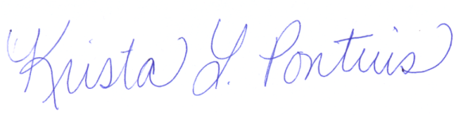
Sincerely,

Krista L. Pontius
First Year Member Jacket Campaign Chairperson
Pennsylvania FFA Alumni Association

Number of Sponsored Jackets: _______ x $75 = _______________

Please indicate if you would like your jackets to support a particular chapter, county, or statewide.

- Chapter(s): _____________________________________________________________________
- County(s): ______________________________________________________________________
- Statewide Support

If your selected chapter or county has more sponsorship than applicants, please indicate if you would like the money returned to you or if you are willing to support a student from across Pennsylvania.
- Please return the money so I can share it with another cause.
- Use the money to sponsor a student from another part of the state.

