FFA Exam Multiple Choice Question Samples

True/False, Multiple choice, Matching

- Turfgrass Identification, Selection, and Morphology
- Cultural practices including mowing, fertility, irrigation, aeration, topdressing, etc.
- Soils
- Drainage
- Turfgrass Mathematics
- Pest Management
- Golf course management
- Sports field management for turf and non-turf areas
- Equipment operation

Which cool season turfgrasses would be best for a shaded home lawn or property in Pennsylvania?
Fine leaf fescues
Tall fescues
Kentucky bluegrass
Annual ryegrass

Why wouldn’t fine fescues be a good choice for athletic fields?
Inability to stripe and make patterns
Poor traffic tolerance
Inability to purchase seed
High nitrogen requirements

Match the Botanical names to the common name

Poa pratensis | Colonial bentgrass
Agrostis canina | Annual bluegrass
Agrostis capillaris | Creeping bentgrass
Festuca arundinacea | Perennial ryegrass
Lolium perenne | Annual ryegrass
Lolium multiflorum | Tall fescue
Poa annua | Kentucky bluegrass
Agrostis stolonifera | Velvet bentgrass
Common Bermudagrass | Eremocholoa ophiuroides
Seashore paspalum | Stenoptaphrum secundatum
Buffalograss | Paspalum vaginatum
St. Augustine grass | Cynodon dactylon
Centipede grass | Zoysia matrella
Manilagrass | Paspalum notatum
Bahiagrass | Buchloe dactyloides

What is a turfgrass’ growth habit if daughter plants are formed by lateral underground shoots?
Rhizomatous
Stoloniferous
Bunch type
None of the above

What is a turfgrass’ growth habit if daughter plants are formed by lateral aboveground shoots?
Rhizomatous
Stoloniferous
Bunch type
None of the above

What is a turfgrass’ growth habit if daughter plants are formed by tillers?
Rhizomatous
Stoloniferous
Bunch type
None of the above

DIAGRAMS:
Identify the structures in the diagrams
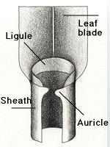

50

51

53

52

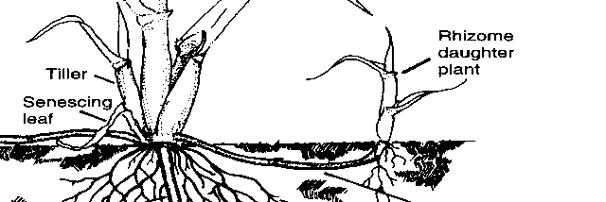
54
55

Place the letter of the proper botanical name for each turfgrass in the corresponding number (not all letters will be used)

What effect does Potassium have on turfgrass?
Increased shoot growth
Increased root growth
Improved germination
Increased stress tolerance
All of the above
B and C

What effect does increasing amounts of Phosphorus have on turfgrass?
Increased shoot growth
Increased root growth
Improved germination
Increased stress tolerance
All of the above
B and C

What effect does increasing (not excessive) Nitrogen have on turfgrass?
Increased shoot growth
Increased root growth
Improved germination
Increased stress tolerance
None of the above
B and C

Which macronutrient is most important in turfgrass growth
Nitrogen
Phosphorus
Potassium
Potash
Calcium

Which of the following is not a primary cultural practice
Mowing
Fertilizing
Cultivation
Irrigating

What should your irrigation strategy be immediately after seeding a new turf stand
Light and frequent amounts of water
Heavy and infrequent amounts of water
Heavy water in the morning, lighter amounts at night
Light water in the morning, heavier amounts at night

How many total pounds of pure live seed (PLS) are in a 40 lb.bag of seed with 92% Pure Seed, 0% Crop seed, 4% Inert matter, 1% Weed seed and 87% Germination?
25 lbs.
40 lbs.
32 lbs.
- bs.

Which is not a physiological response to turf growing in a shaded environment?
Thinner leaves
Fewer stomata
Shallower root system
More upright growth

How many pounds of N are in a 50 lb bag of fertilizer with an analysis of 14-10-8?
2.4
3.5
7
8
14
10
None of the above

How much topdressing is needed to topdress 175,000 ft² of greens with a light (1/16 inch) topdressing?
34 cu.yds.
102 cu.yds
405 cu.yds
911 cu. yds.
None of the above

A 20-2-15 fertilizer is to be applied to the fairways at 0.75 lbs N/1000ft². There are 43 acres of fairways. How much fertilizer will be needed?
1405 lbs
7024 lbs
281 lbs
4200 lbs
None of the above

The appearance of white bands with reddish-brown margins across the leaves is symptomatic of:
leaf spot and melting out
powdery mildew
rust
dollar spot
red thread

The appearance of circular areas of bleached leaves discoloring and shriveling from the tips, and matted together by pink, gelatinous mycelial growth is symptomatic of:
leaf spot and melting out
powdery mildew
rust
dollar spot
red thread

Which white grub species that attacks golf course turfgrass (bentgrass, P. annua) has multiple generations per year?
Japanese beetle
Northern masked chafer
Black turfgrass ataenius
Green June beetle

Chinch bug damage appears as:
Wilting
Chewed or notched foliage
Shrunken roots
Chlorotic leaves
Galling on the roots

