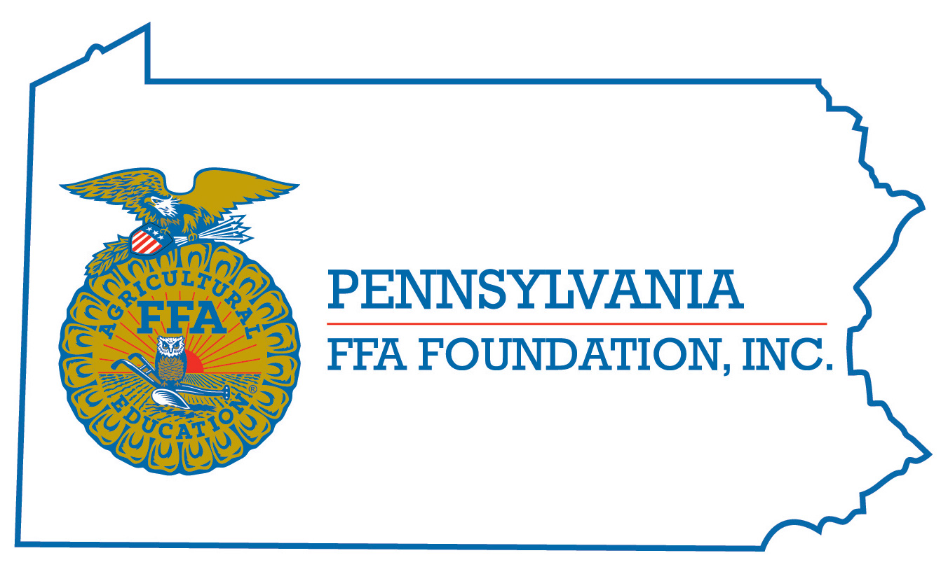

Board Candidate Profile

Instructions: Please answer all questions in this Board Candidate Profile and return the completed form to Sarah Sparks, ssparks@paffafoundation.org, at your earliest convenience. Please also attach your resume.

Date: _____________________________

General
Name:
Home Address (Street, City, State, Zip):
Home Phone: ( ) -
Cell Phone: ( ) - Is this a good way to contact you? Yes or No
Home e-mail Is this a good way to contact you? Yes or No

Employment
Employer:
Position:
Work Address (Street, City, State, Zip)::
Work Phone: ( ) -
Work e-mail Is this a good way to contact you? Yes or No

Education
Name and Degree/Major:

Non-profit Board and Committee Volunteer Experience:
List other not-for-profit organizations with which you are/were associated. Please indicate positions served (Board member, committee member, etc.)
Organization Position Dates

Fundraising Volunteer Experience:
List fundraising/development activities with which you are/were associated. Please indicate your role and the type of fundraising (annual campaign, capital campaign, special event, etc.).
Organization Type of Activity Your role Dates

Experiences/Skills:
List other community, civic, professional, and social organizations with which you are/were associated. Please indicate positions held.
Organization Position Dates

List hobbies, other interests and skills, particularly those which may have a possible application to the FFA Foundation:

Why do you want to join the Pennsylvania FFA Foundation Board of Directors?

Please return completed profile to:

PA FFA Foundation
Sarah Sparks, Executive Director
ssparks@paffafoundation.org

Or by mail:
PO Box 157
East Berlin, PA 17316

(cell) 717.781.5780

